Dear Parents,
We will be making relief maps of Utah. To do this, I need to have the students make their clay at home. Could you help your child with this project? Sometimes students are unable to make their own clay due to unforeseen problems that come up. It would be very helpful if some of you would be willing to make two batches of clay. If there is a problem, please let me know. Thank you!!!

This recipe can be made ahead of time and kept in the refrigerator.

2 cups water
2 cups flour
1 cup salt
½ cup cornstarch
2 Tablespoons vegetable oil
1 Tablespoon powdered alum (found in the spice section of the store)

- Mix all ingredients
- Cook over medium heat until clay thickens
- Remove from pan and knead until smooth
- Store in an airtight container or zip lock bag
- DO NOT color the clay

We will soon be making and painting our maps at school.
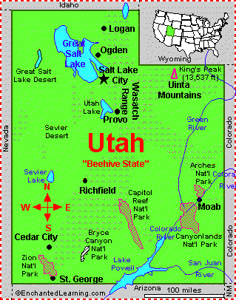
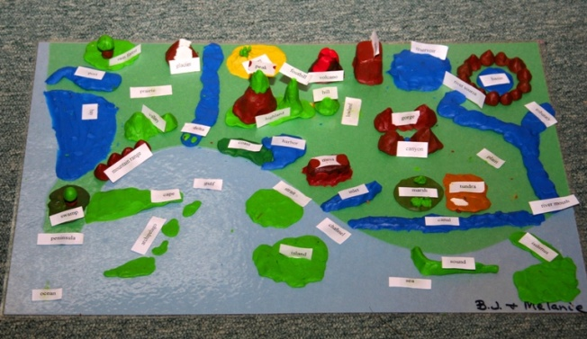
Thank you,

Ms Nielsen

